**New York State Warns Residents About Fake Letters In Tax Scam**

**The letters threaten that personal property could be levied and sold, with drivers' licenses and passports revoked, state says.**

By [Lisa Finn, Patch Staff](https://patch.com/users/lisa-finn-221e4bec)

Aug 30, 2019 2:58 pm ET | Updated Aug 30, 2019 8:47 pm ET

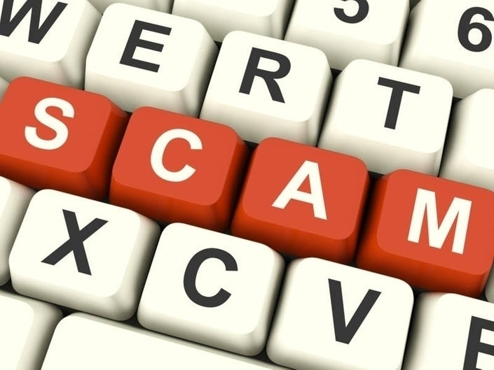((Stuart Miles/Shutterstock))

<https://patch.com/new-york/northfork/new-york-state-warns-residents-fake-letters-tax-scam>

NEW YORK STATE —The New York State Department of Taxation and Finance is warning residents to beware of fake letters sent out in a tax scam.

The letters demand immediate payment for an outstanding tax debt and threaten revocation of passports and drivers' licenses if the warning is ignored, the state said.

The return address on this letter, which was sent to at least one person, is:

Tax Processing Center  
Internal Processing Service  
Public Judgement Records

In addition, the state says, the letter states that the recipient has failed to respond to prior notices, demands full payment by a specific date, and provides an 888 number to call to avoid having personal property levied and sold. It also threatens to revoke the recipient's driver's license and passport.

A copy of the scam letter can be seen [here](https://www.tax.ny.gov/pdf/press/scam-notice-082019.pdf). To view copies of other similar scam letters sent to New York taxpayers, click [here](https://www.tax.ny.gov/pdf/press/scam-notice-122018.pdf).

"This is a common scam in which the recipient is threatened out of the blue with punitive action unless payment—in this case, $12,444 —is made immediately," said New York State Commissioner of Taxation and Finance Michael Schmidt. "In contrast, our department works with taxpayers who have existing tax debt, such as by establishing an installment payment agreement, to resolve the issue. We also work with all levels of law enforcement to bring the fraudsters who commit these types of crimes to justice."

<https://patch.com/new-york/northfork/new-york-state-warns-residents-fake-letters-tax-scam>

<https://patch.com/new-york/northfork/new-york-state-warns-residents-fake-letters-tax-scam>

The Tax Department also routinely explains a taxpayer's right to challenge a bill or notice, or other departmental actions, and offers several ways to pay a bill.

The tax department never threatens arrest or revocation of passports. A legitimate letter from the department will include the tax department logo; an option to respond online, by phone, or by mail; the tax department's website address; a detailed explanation for why it was sent; and an explanation of taxpayers' rights.

Con artists will often try to impersonate representatives from the tax department or IRS, the state added.

"If you receive a suspicious letter from someone claiming to be an employee of either agency, it's critical that you report it," the state said.

Possible scams can be reported to the tax department and IRS online or by phone; complaints will be reviewed promptly and, if appropriate, corrective action will be taken.

If you receive a suspicious letter that claims to be from the NYS Tax Department, contact the tax department by phone at 518-451-1566 or by email at [dtfoia@tax.ny.gov](mailto:dtfoia@tax.ny.gov).  
  
Scammers have also claimed to be from the New York State Treasury. If you receive one of those calls, notify the agency at 1-800-771-7755. The Federal Trade Commission should also be alerted. A complaint can be filed on the [FTC](http://www.ftc.gov/complaint) website or by calling 1-877-FTC-HELP (1-877-382-4357).

<https://patch.com/new-york/northfork/new-york-state-warns-residents-fake-letters-tax-scam>